**Meeting 09/08/2016**

**Agenda:**

* OGA version of the combined Scope (Nelya)
* User-friendly interface for active hyperlinks
* Creation of the Revision form in FB and promotion of the Revision module
* Navigation possibilities
* If we have time => clarification question related to filtering the dummies from GreenSheets

Contents

**User-friendly interface for active hyperlinks** 2

**Creation of the Revision form in FB and promotion of the Revision module** 8

**Navigation possibilities:** 12

**Filtering of the dummies from GreenSheets system** 17

## **User-friendly interface for active hyperlinks**

**Good news:**

* Currently users add url to a question using “Learn more” field in Add/Edit Question screen in Form Builder. We can embed a WYSIWYG editor instead of text area for "learn more" field. Something like at <http://jwysiwyg.github.io/jwysiwyg/help/examples/01-basic.html>; we can control available formatting, leaving only basic text formats (bold, bullets, links, etc.)
* We can make sure that active link in Form Builder will stay active when passed to GreenSheets

From this: 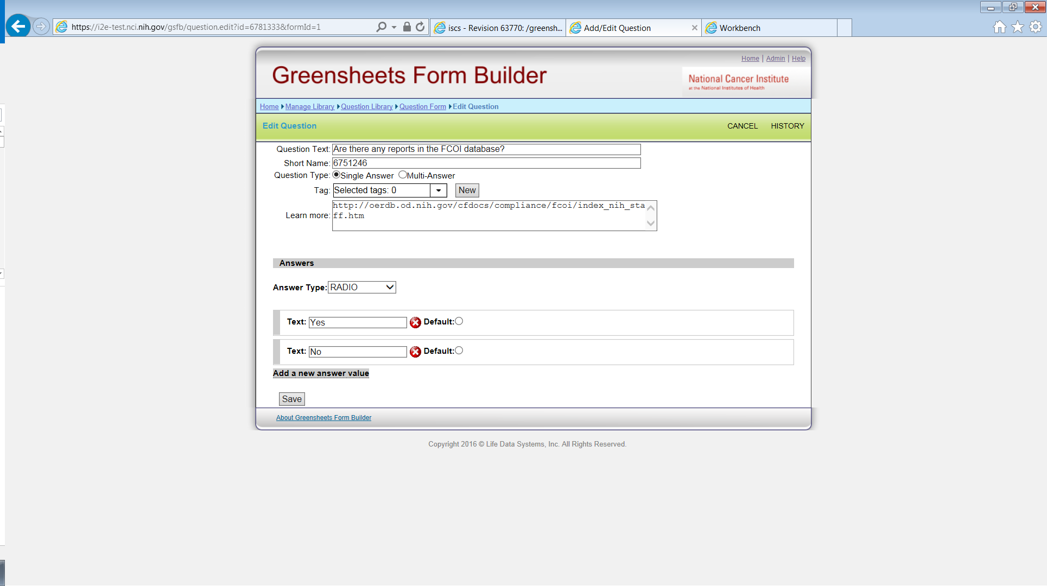

To this: 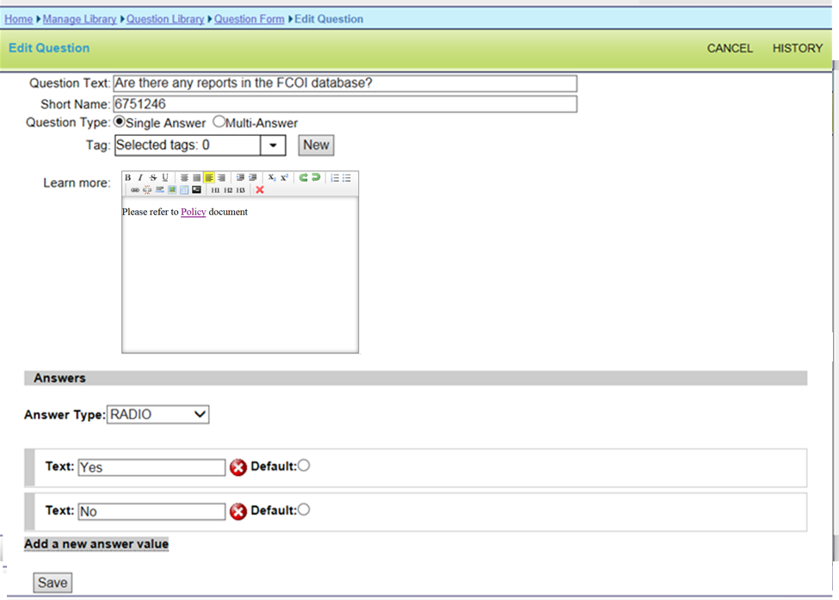

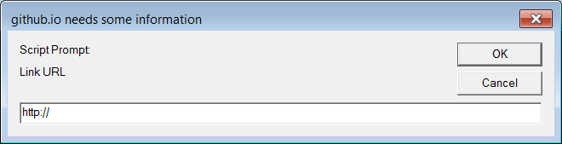

**Question:** To propose the rest of related modifications, CBIIT needs to understand what is the business flow for adding/modifying active hyperlinks? E.g.:

* 1. **Per form:** Are users going to open the module => open each form => find the question within the form that has URL => modify one form at a time and redeploy one module at a time? The limitation for this method is that new content will not get propagated to all other forms where this question is used (even if this question is linked to the libraries). *If this workflow will be used, we need to add editor to the “learn more’ field for question* ***in the form***.

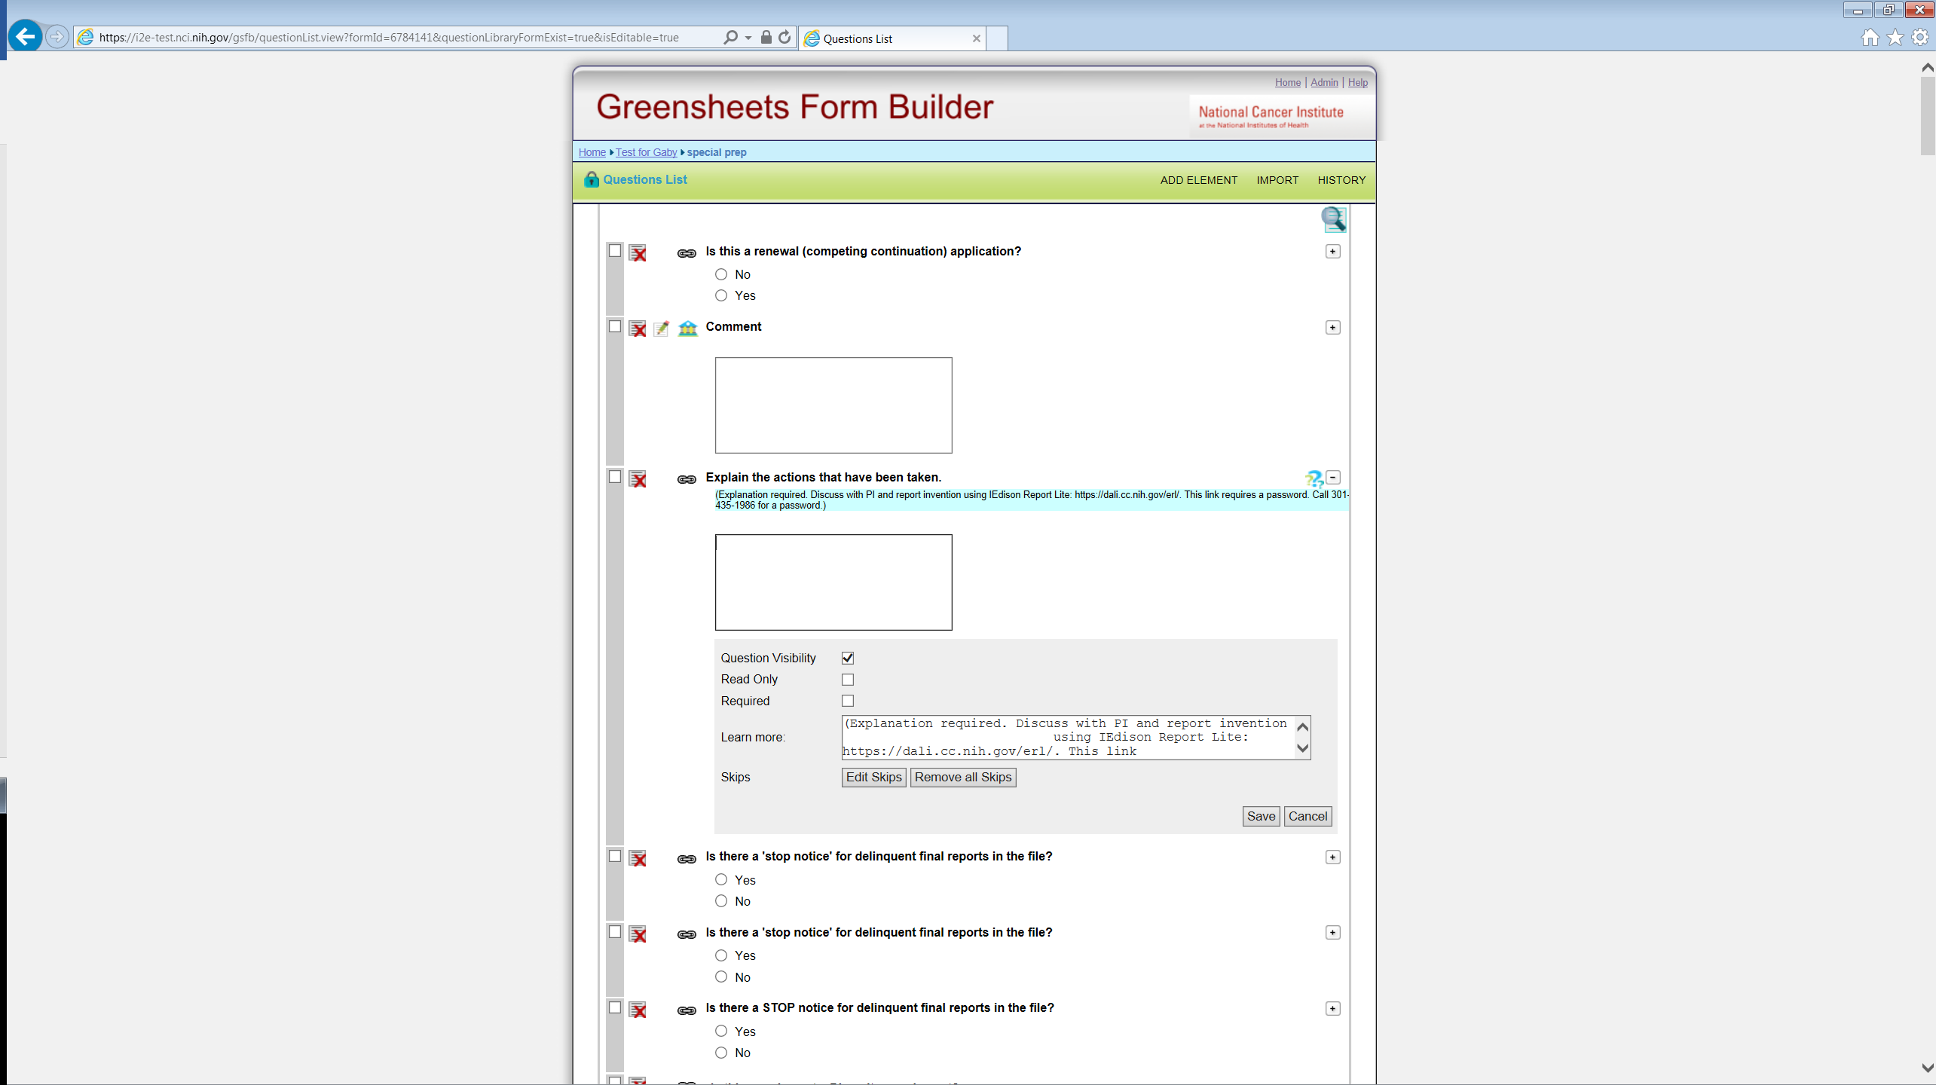

or

* 1. **Per section:** Do users want to open the question in the section library, have information about all forms/modules/type/mechs where this section is used => add/modify hyperlink for the question in the section => it will update all forms => redeploy all affected forms/modules? *In this case we, probably, will need to modify the search for the questions in the section (include keywords form “Learn More” field), provide better indication of usage on this* ***section*** *page (in which forms/modules/type/mechs this section is used), add editor to the “learn more’ field for question in the section, and add extra validations.*

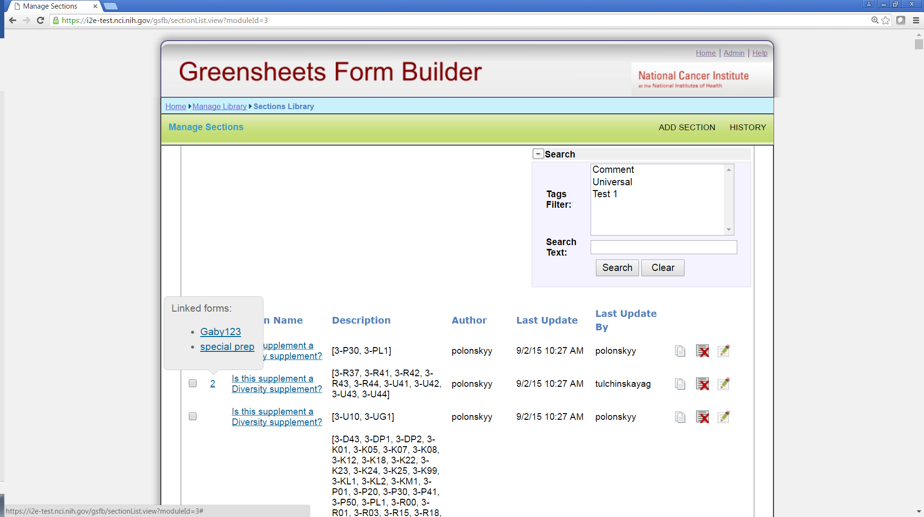

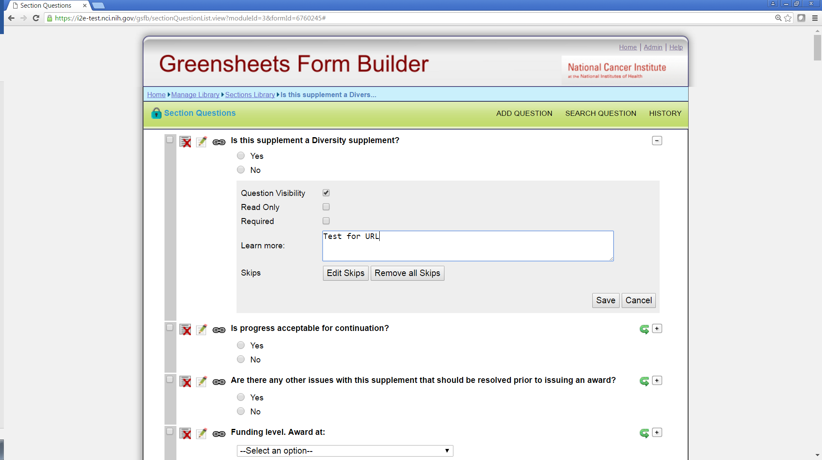

Or

* 1. **Per question in the question library:** Do users want to open the question in the question library, have information about all forms/modules/type/mechs where this question is used => add/modify hyperlink for the question => it will update all forms => redeploy all affected forms/modules? *In this case we will need add editor to the “learn more’ field for question in the question library, provide better indication of usage on this* ***question*** *page (e.g. extend History functionality), and add extra validations*

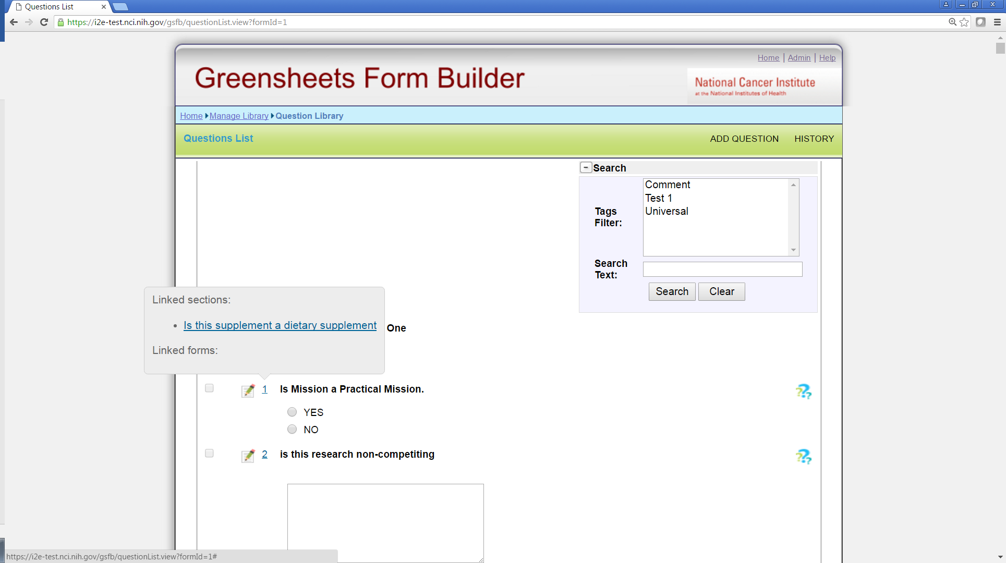



## **Creation of the Revision form in FB and promotion of the Revision module**

This proposal is based on the requirements:

* Only one revision form is needed for all type/mechs
* Revision form will be used by Specialist only

**Proposed workflow**

**OGA user** will (see mockups below):

* create a new module in FB (user can call it “Revision module”, but this is “as-is” functionality, no changes)
* create a form (user can call it “Revision form”, but this is “as-is” functionality, no changes)
* The only change for a user => add new **category of revision type, select ALL type/ALL mech combination to a form, and add Revision form to this category**
* add Revision form to Revision module (no changes)
* deploy the module as usual

**Changes to create a category process**

The system will allow to select ALL types and mechanisms while creating a category.

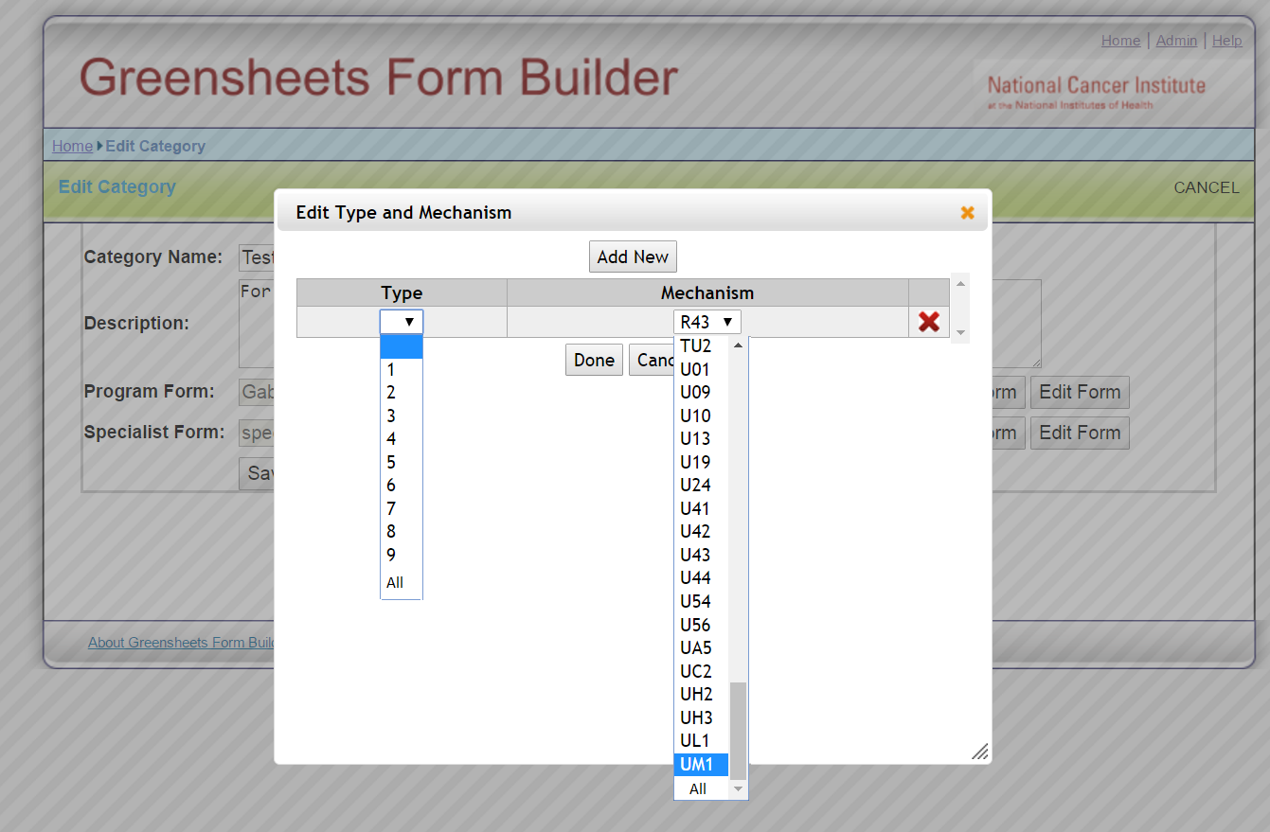

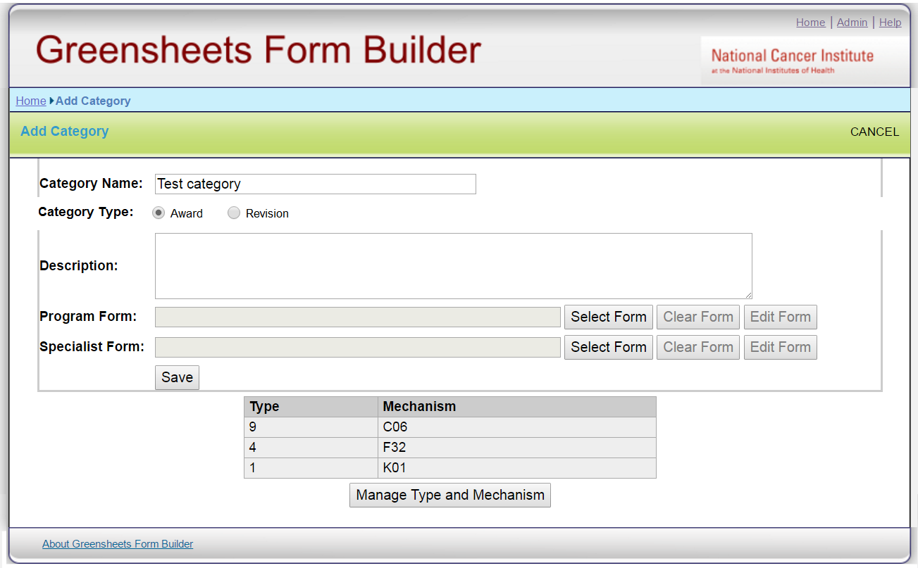

When OGA user adds a category, s/he may choose a category type (Award or Revision)

On the screen category type will be defaulted to ‘Award’ (OGA mentioned that after Revision form is created and deployed, it will never change).

* If ‘Award’ type is chosen, the process is as usual
* If “Revision” type is chosen:
* The screen will allow adding only Revision form
* User will select ALL types/mechanisms (no validation for ALL/ALL combination, it will be responsibility of the user, it will allow more flexibility in the future)

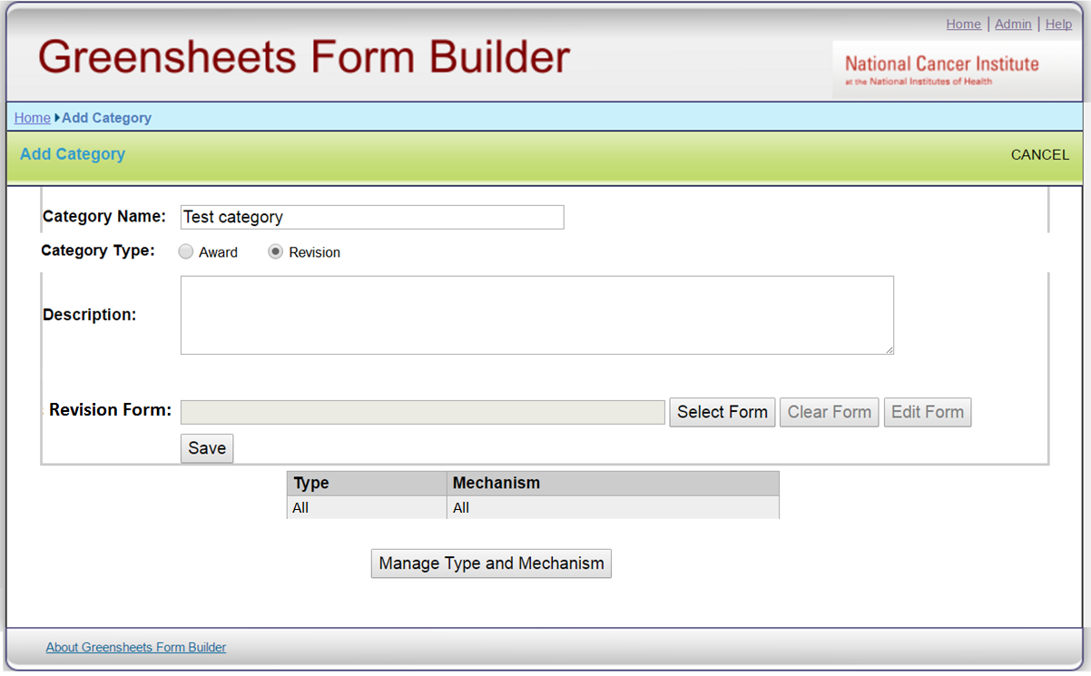

**Question:** do we need to make category type read-only when editing existing category? Or do we need to restore type/mechs in a category **BEFORE SAVE** if user accidentally switched from AWARD type to Revision and back to AWARD?

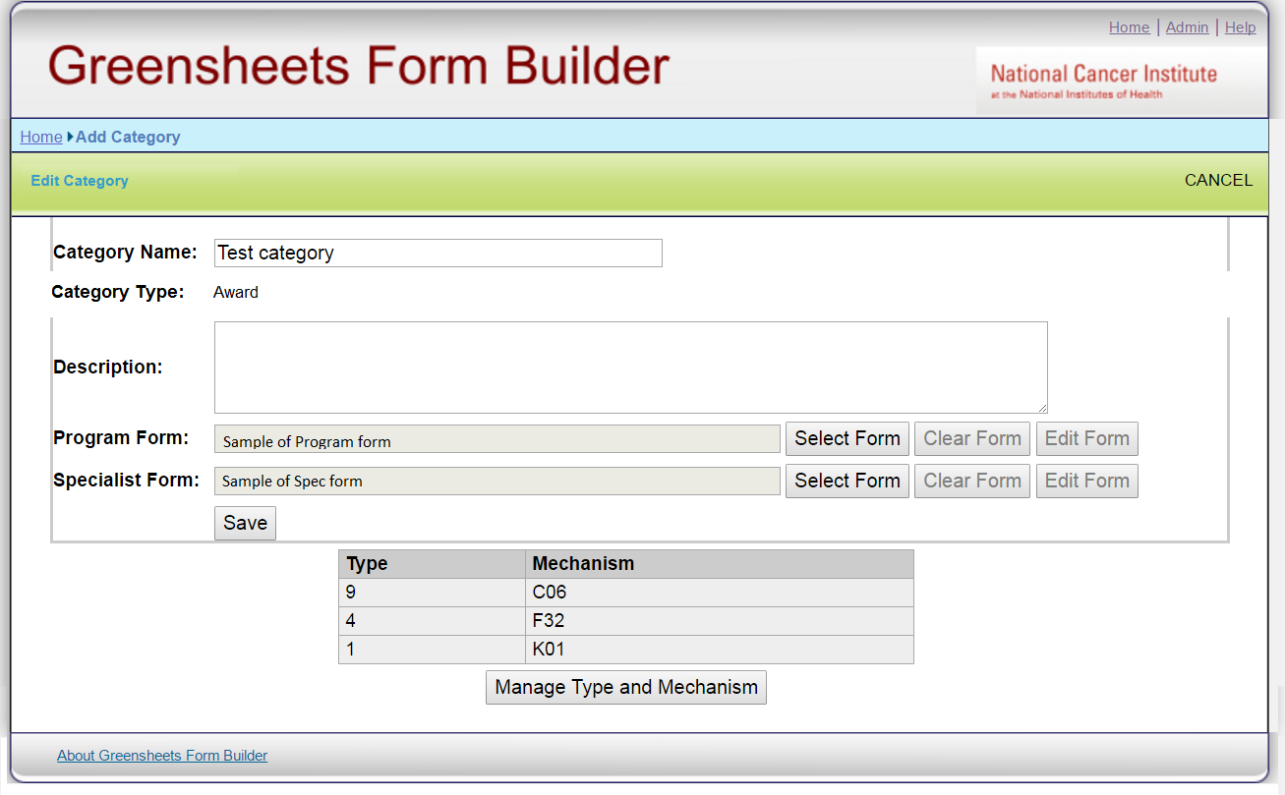

## **Issues related to navigation:**

* **Browser window when navigating to a greensheet from other system(s)**

Currently, if user navigates to a greensheet via Your Grants or Notifications, user can first perform a search by greensheet status. Resulting hit list will display grants with greensheets in selected status.

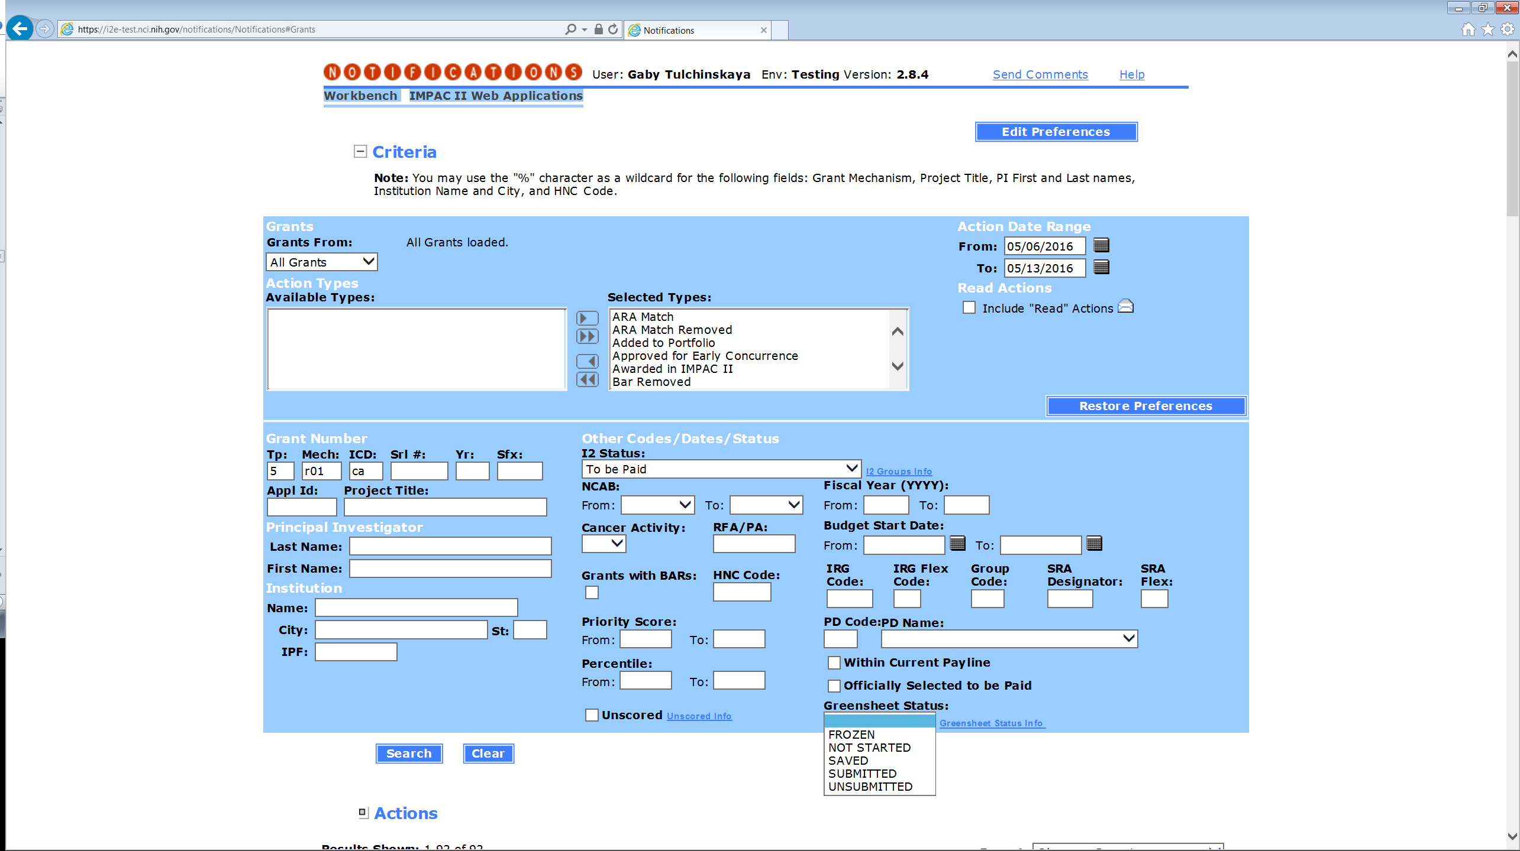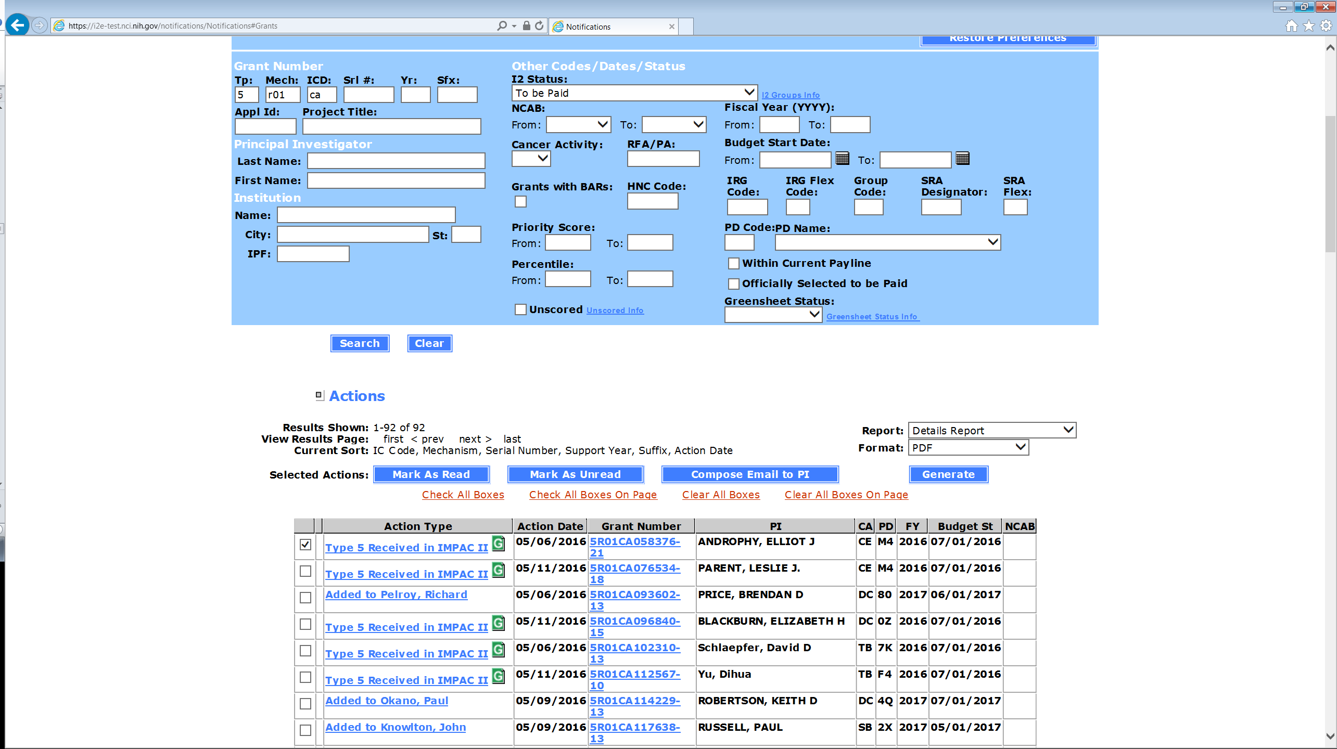

If user clicks “G” icon, the system opens this greensheet in a separate browser window. If user makes changes resulting in change of greensheet status, user will close greensheet window, but nothing will change on a hit list in Your Grants. Can we keep existing implementation or is it a problem?

* **Navigation between a specific greensheet and Grants List screen**

**Questions**:

1. Currently a user can navigate to a hit list screen only via Workbench. Majority of SPECIALISTS navigate to a specific greensheet via eGrants or (in the future) via GPMATS. Is there any value in having hit list screen at all or should we get rid of it?
2. **If we need to keep a grants list screen for Specialists**, we need to address several issues:
   1. **Navigation FROM a grant list screen to a greensheet and back**

Current implementation: if user clicks greensheet icon on a grant list screen, the system opens a greensheet in a separate browser window. User performs some actions (Save or Submit) that change the STATUS of greensheet. User closes a greensheet window and hitlist displays OLD status. This is confusing.

Proposed new rule: if user clicks greensheet icon on a grant list screen, the system will open a greensheet in the SAME window.

Result: User performs some actions (Save or Submit) that change the STATUS of greensheet => When this user navigates back to a grant list screen, it will reflect the correct status

Needed change: Currently there is no way to navigate back to a Grants List. Can we add a navigation link allowing to go back to a grants list?

How it will look? 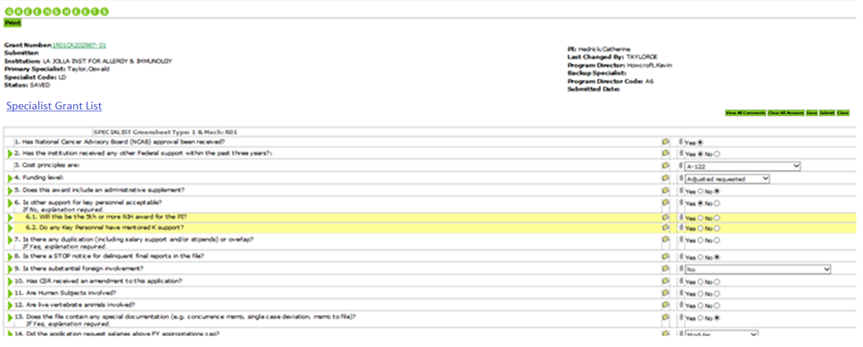

* 1. **Should Revision greensheet be displayed on grants list (see mockup below)?** From the meeting minutes about revised awards: “*OGA will evaluate the need to display revision awards on the hit list screen, maybe only AWARD actions will be displayed*.”
     + If yes (display Revision greensheets on a hit list), should greensheets record display any additional information about revision action (e.g. OGA award release date)?
     + If no (do NOT display Revision greensheets on a hit list), do we need any changes to the screen at all (e.g. somehow indicate that revisions exist for certain grants)?

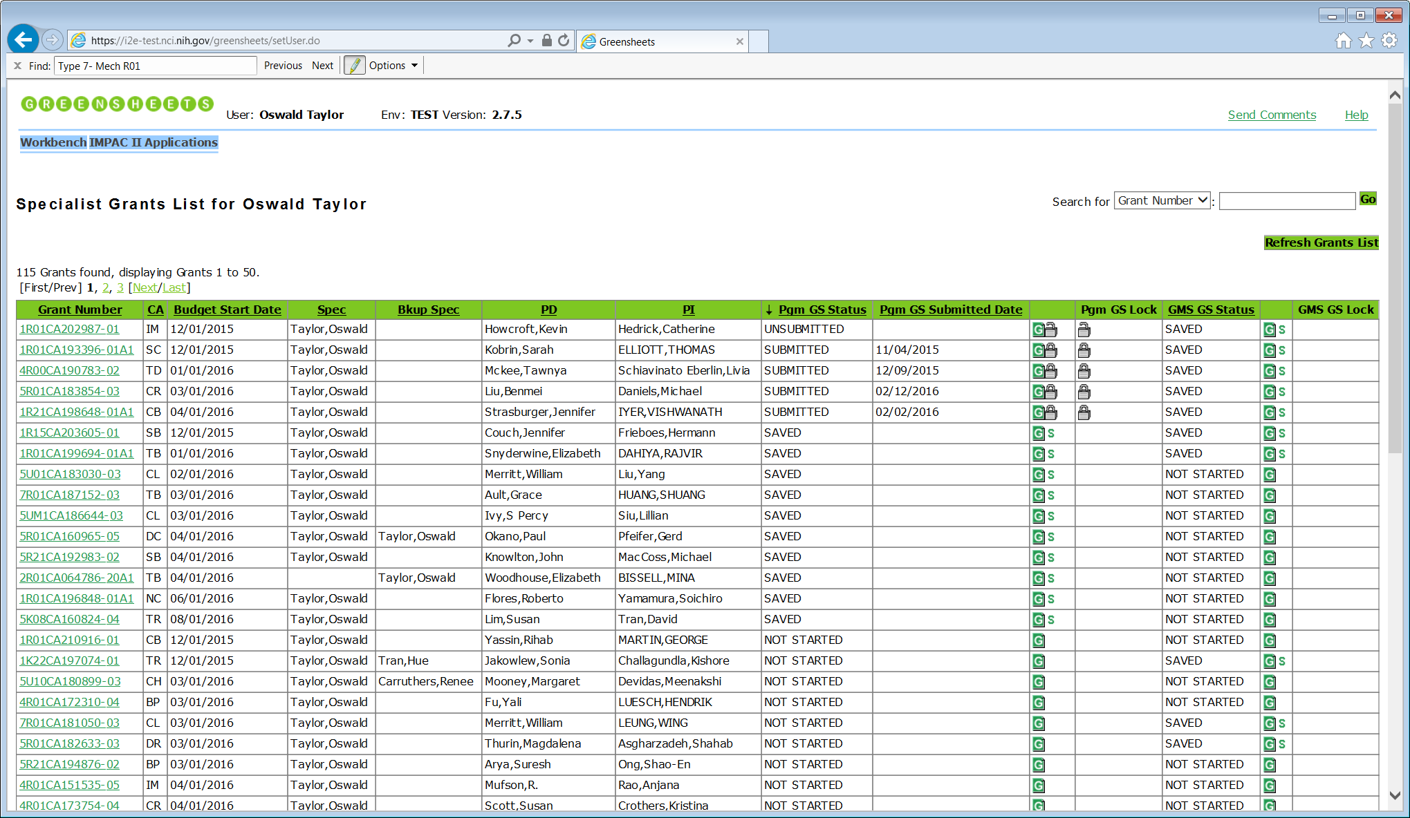

|  |  |  |  |  |  |  |  |  |  |  |  |  |  |  |  |
| --- | --- | --- | --- | --- | --- | --- | --- | --- | --- | --- | --- | --- | --- | --- | --- |
| **Grant Number** | **CA** | **Budget Start Date** | **Spec** | **Bkup Spec** | **PD** | **PI** | **GPMATS Action Type** | **OGA Award Release date** | **Pgm GS Status** | **Pgm GS Submitted date** |  | **Pgm GS Lock** | **GMS GS Status** |  | **GMS GS Lock** |
| 1R01CA202987-01 | IM | 12/01/2016 | Taylor, Oswald | Clark, Patty | Liu, Grace | Tran, David | Award | 5/29/2015 | FROZEN | 11/04/2016 |  |  | FROZEN |  |  |
| Revision/ Term change | 2/03/2016 |  |  |  |  | FROZEN |  |  |
| Revision/ Co-fund |  |  |  |  |  | SAVED |  |  |
| 5R01CA123456-04 | CE | 12/01/2016 | Clark, Patty | Perry, Carol | Hubbard, Leah | Wu, Tzyy | Award |  | SUBMITTED | 11/04/2016 |  |  | SAVED |  |  |
| 5R01CA077476-03A1 | CB | 12/01/2016 | Clark, Patty |  | Hubbard, Leah | Woo, Tong | Award | 2/03/2016 | FROZEN | 11/04/2016 |  |  | FROZEN |  |  |
| Revision/ Co-fund |  |  |  |  |  | SAVED |  |  |

* 1. **Is there a need to navigate FROM a specific greensheet TO a grants list when user navigates to a specific greensheet via eGrants or via GPMATS?**

If yes (ability to navigate **FROM** a specific greensheet **TO** the hit list IS needed), which records should be displayed on the hit list (see the rules below)?

|  |  |  |
| --- | --- | --- |
| Navigate FROM: | Link name proposal | When user clicks this link, the records to display on the hit list |
| Specialist greensheet | Specialist Grant List | User (Grants Management Specialist) is assigned as either the primary or backup specialist for the grant.  AND  The status of the "*specialist*" greensheet(s) are NOT STARTED and/or SAVED and/or UNSUBMITTED  AND  Grant(s) are "in GPMATS" (meaning that either AWARD or REVISION action exists (currently it’s just AWARD)) |
| Revision greensheet | Specialist Grant List | There is a dependency on the decision if Revision greensheets will be displayed on the hit list or not. If Revision greensheets are not displayed on the hit list, such link will become a one-way street => user will be able to FROM a greensheet to the hit list, but wouldn’t be able to go back to a Revision greensheet.  Question: Should we provide a link to a screen with the hit list if Revision greensheets are not displayed on it? |
| Program greensheet | Program Grant List | Assumption is that we will keep existing rules. The only change will be that we will filter dummies. |

## **Filtering of the dummies from GreenSheets system**

Is the requirement to allow Program staff to begin completing a greensheet ‘in advance’ (before any AWARD action is added in GPMATS to a real grant) is no longer needed?